**Welcome To The Registrar Operating System**

MAIN MENU AND SYSTEM FOR THE REGISTRAR:

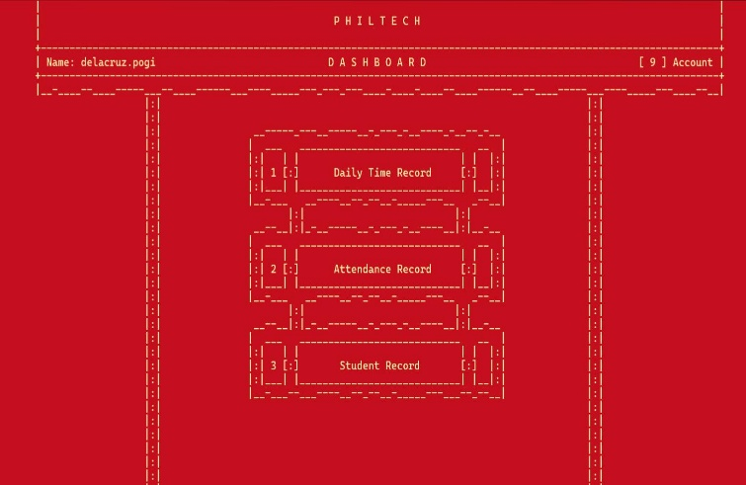1. Daily Time Record (1): This section is presumably for recording daily work hours or time spent on tasks.

2. Attendance Record (2): This section is likely for recording attendance, possibly marking employees as present or absent. Further details are not available.

3. Student Record (3): This section suggests the system may be used in an educational setting, possibly for managing student information. Specific features are unknown.

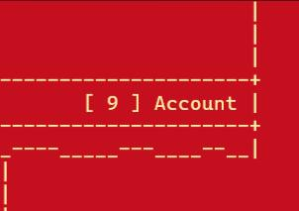The “[9] Account” section in the upper right corner likely provides access to account settings, such as profile management and inbox. The specific options within this section are not show.

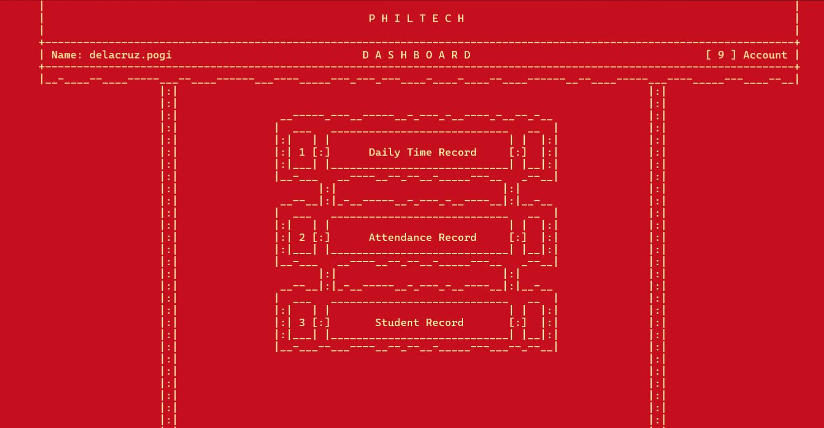The first is The Daily Time Record System, Input [1]

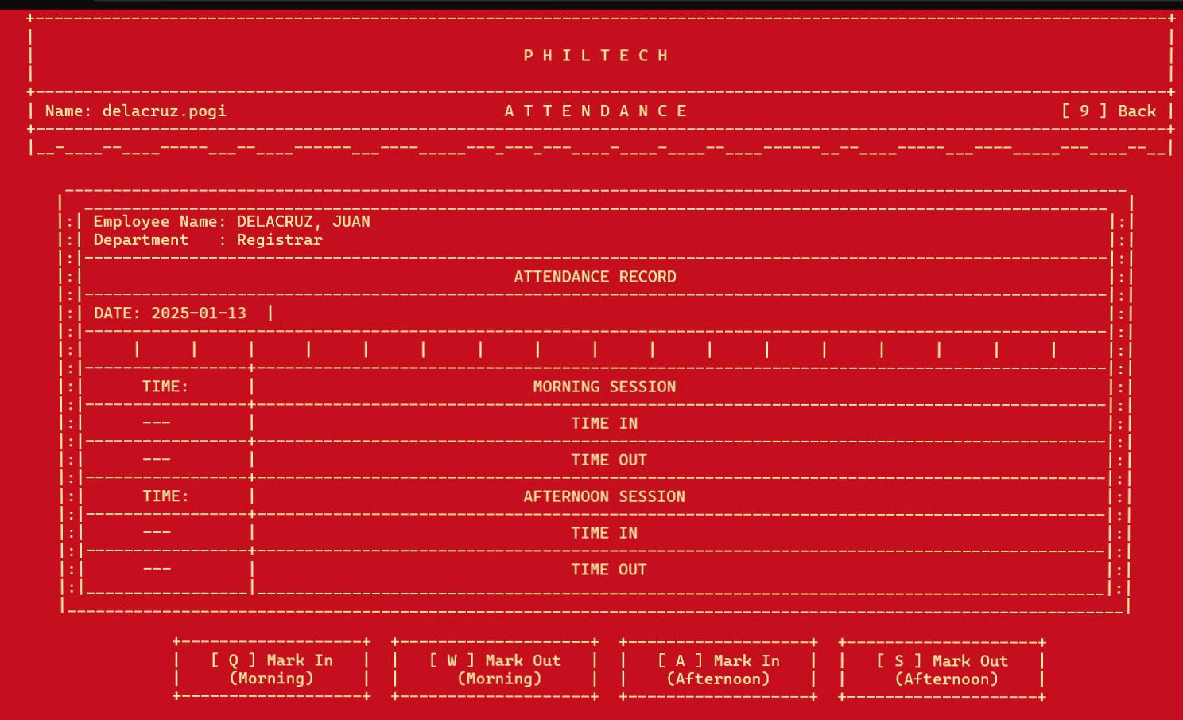The main Daily Time Record Screen.

- Employee Information: Displays the employee’s name (e.g., DELACRUZ, JUAN) and department (e.g., Registrar).

- Date: Shows the current date for attendance recording (e.g., 2025-01-13).

- Attendance Record: A table to record attendance for morning and afternoon sessions. Each session requires a “Time In” and “Time Out” entry.

- Marking Attendance: Buttons are provided for marking attendance:

-  [Q] Mark In (Morning)

-  [W] Mark Out (Morning)

-  [A] Mark In (Afternoon)

-  [S] Mark Out (Afternoon)

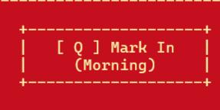1. Marking Attendance.

- To record your time in for the morning session, click the  [Q] Mark In (Morning)  button. The system will automatically record the current time.

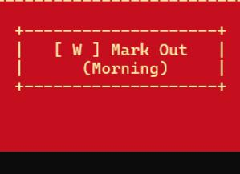

- To record your time out for the morning session, click the  [W] Mark Out (Morning)  button. The system will record the current time.

- Follow the same procedure using  [A]  and  [S]  for the afternoon session.

2. Back Button:

-The  [9] Back  button in the upper right corner allows you to return to the main PHILTECH dashboard.

Next Is The Attendance Record, Input [2]

This describes the PHILTECH Attendance Record Report screen, as shown in the image. This screen displays a summary of student attendance.

2. Report Information:

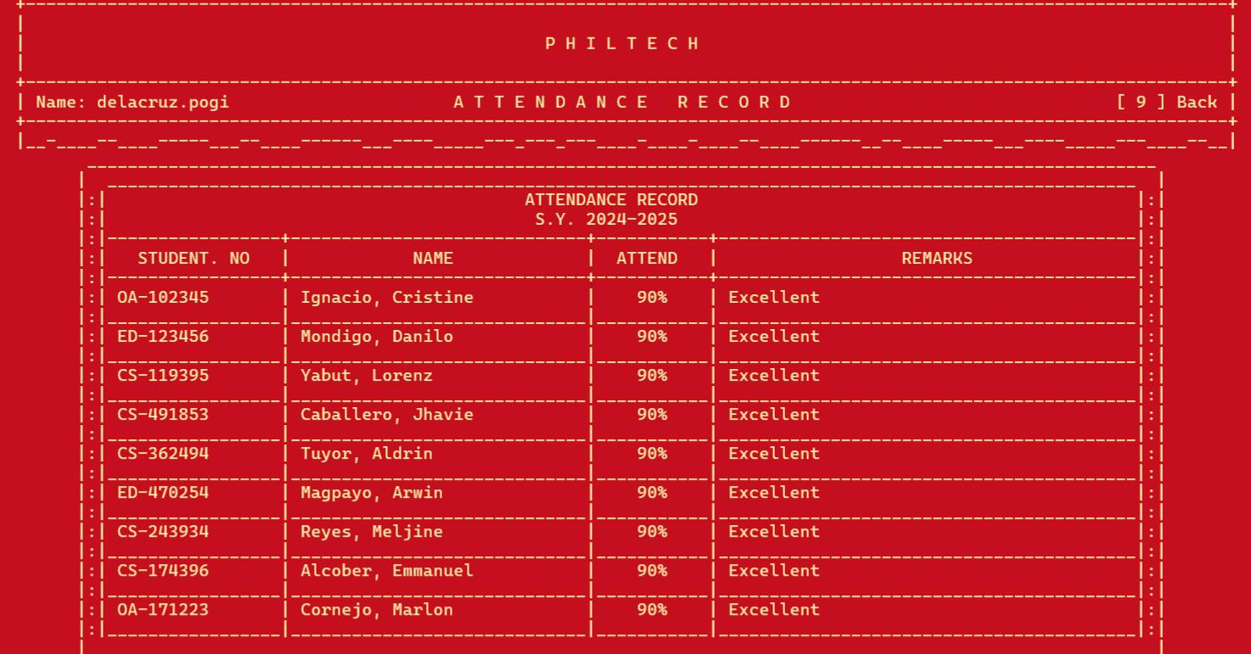- Student No: The student’s unique identification number.

- Name: The student’s full name.

- Attend: The student’s attendance percentage. The example shows all students with 90%.

- Remarks: A column for comments or observations regarding the student’s attendance. In the example, all students have “Excellent” remarks.

4. Navigation:

The  [9] Back  button in the upper right corner allows you to return to the previous screen (likely the main PHILTECH dashboard).

**Next Is the Student Record,Input[3]**

This manual details the use of the PHILTECH Student Record System, as shown in the provided image. This screen displays a list of students and their information.

Student records

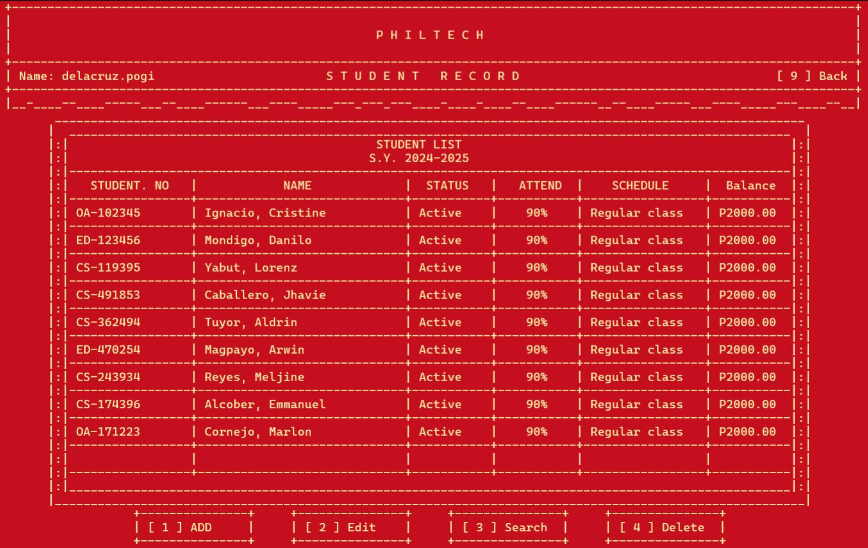The system displays the following information for each student:

- Student No: The student’s unique identification number.

- Name: The student’s full name.

- Status: The student’s current status (e.g., “Active”).

- Attend: The student’s attendance percentage.

- Schedule: The student’s class schedule (e.g., “Regular class”).

- Balance: The student’s outstanding balance (e.g., “P2000.00”). This likely represents fees or payments.

4. System Functions:

The following functions are available:

-  [1] Add : Adds a new student record to the system.

-  [2] Edit : Edits the details of an existing student record.

-  [3] Search : Searches for a specific student record.

-  [4] Delete : Deletes a student record from the system.

5. Navigation:

The  [9] Back  button in the upper right corner allows you to return to the previous screen (likely the main PHILTECH dashboard).

This manual details how to add a new student record using the PHILTECH Student Record System

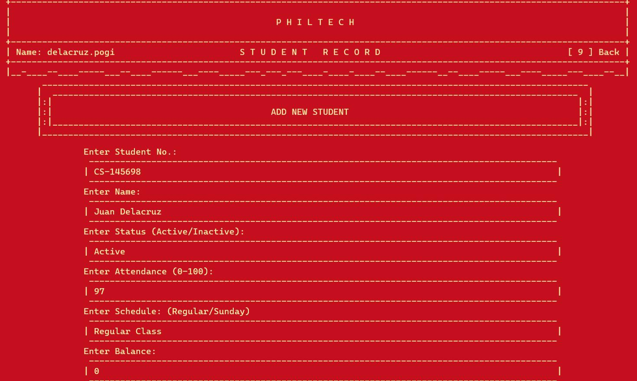1. Required Information:

To add a new student, you must provide the following information:

- Enter Student No.: Enter the student’s unique identification number. The example shows “CS-145698”. The prefix (e.g., “CS-“) may indicate the student’s course or department.

- Enter Name: Enter the student’s full name. The example shows “Juan Delacruz”.

- Enter Status (Active/Inactive): Select the student’s status. The options are “Active” or “Inactive”. The example shows “Active”.

- Enter Attendance (0-100): Enter the student’s attendance percentage (a number between 0 and 100). The example shows “97”.

- Enter Schedule: (Regular/Sunday): Select the student’s class schedule. The options are “Regular” or “Sunday”. The example shows “Regular Class”.

- Enter Balance: Enter the student’s outstanding balance. The example shows “0”. The currency is not specified in the image.

2. Navigation

* The  [9] Back  button in the upper right corner allows you to return to the previous screen (likely the main PHILTECH Student Record screen).

3. Saving Notice:

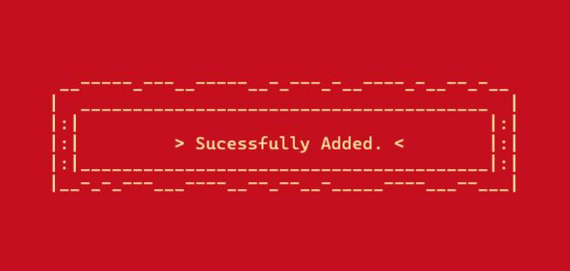

* This message likely appears after successfully adding a new student record or completing another data entry task. No further actions are needed from the user at this point. The user should proceed to the next task or navigate back to the Student Record.

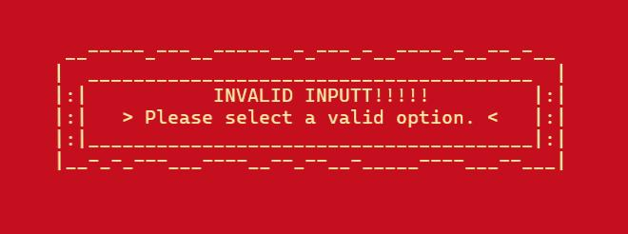

This error message appears when the user has entered incorrect data or selected an invalid option within the system. The user needs to review their previous input and correct any errors before continuing. The specific location of the error is not identified in the message. The user should check all their inputs on the previous screen.

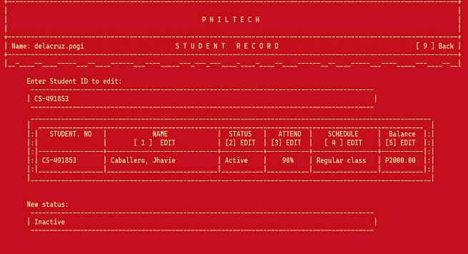This manual details how to edit an existing student record using the PHILTECH Student Record System.

How To Edit?

1. Selecting a Student:

* Enter the Student ID of the student you wish to edit in the “Enter Student ID to edit:” field. The example shows “CS-491853”.

3. Editable Fields

Once the student is selected, their record is displayed, and the following fields are editable:

- [1] EDIT Name: Edit the student’s name.

- [2] EDIT Status: Change the student’s status (Active/Inactive). The example shows changing the status to “Inactive”.

- [3] EDIT Attend: Modify the student’s attendance percentage.

- [4] EDIT Schedule: Change the student’s schedule (Regular/Sunday).

- [5] EDIT Balance: Update the student’s balance.

3. Saving Notice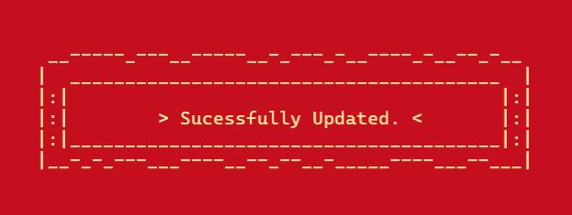

The image shows a success message: “Successfully Updated.” This indicates a successful updated the Existing Student Record

5. Navigation:

The  [9] Back  button in the upper right corner allows you to return to the previous screen (likely the main PHILTECH Student Record screen).

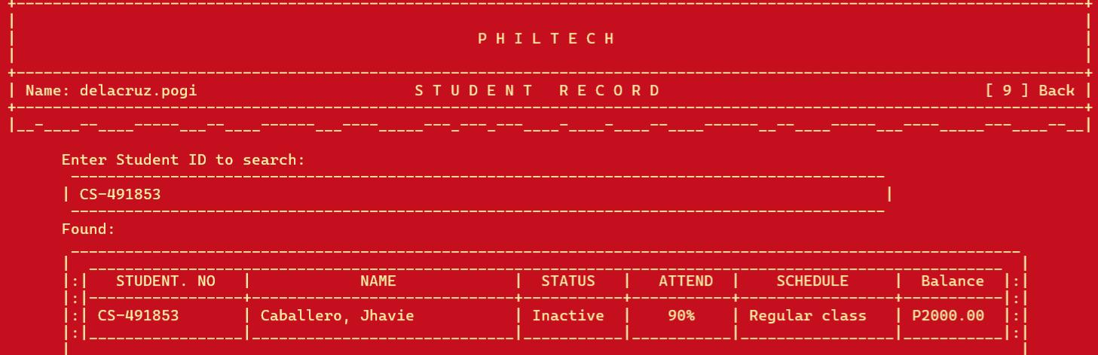This manual details how to search for a student record using the PHILTECH Student Record System, as shown in the image.

How to Search?

3. Search Results:

* If a student matching the entered ID is found, their record is displayed under the “Found:” label. The displayed information includes Student No., Name, Status, Attend (attendance percentage), Schedule, and Balance. The example shows student “Caballero, Jhavie” with ID “CS-491853”.

4. No Results:

* If no student matches the entered ID, the “Found:” section will likely be empty or display a “Not Found” message

5. Navigation:

 The  [9] Back  button in the upper right corner allows you to return to the previous screen (likely the main PHILTECH Student Record screen).

The Last Is Delete

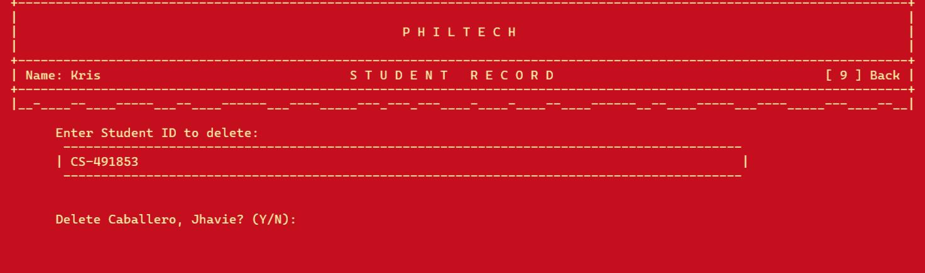This manual details how to delete a student record using the PHILTECH Student Record System, as shown in the image

How To Delete?

2. Selecting a Student

* Enter the Student ID of the student you wish to delete in the “Enter Student ID to delete:” field. The example shows “CS-491853”.

3. Confirmation:

* After entering the Student ID, a confirmation message appears: “Delete Caballero, Jhavie? (Y/N):” This prompts the user to confirm the deletion.

4. Deletion :

* To delete the student record, enter “Y” (for Yes). To cancel the deletion, enter “N” (for No). The result of this action is not shown in the provided image.

5. Navigation:

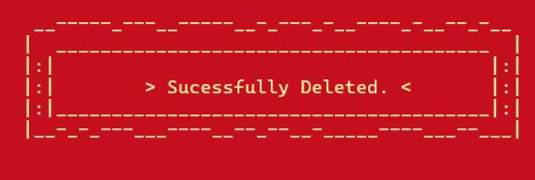The  [9] Back  button in the upper right corner allows you to return to the previous screen (likely the main PHILTECH Student Record screen).

Deletion Notice:

This message appears after the user confirms the deletion of a student record. No further actions are needed from the user at this point.

**That all for the Registrar System Program**